Title: | Window Lifter  SW Component < XXXXXXX >

History
Issue status  (Index) | Maturity/Date  (draft/invalid/valid)  (dd-mmm-yyyy) | Author  Department | Check/Release  Department | Description
1.0 | Draft  04-0ct-09 | Miguel Garcia | Miguel Garcia | Creation of the document
1.1 | Draft  29-Jun15 | Pedro Romero | Francisco | First Release of Template

Table of Contents
1 Purpose 4
2 Definitions and abbreviations 4
3 Realization constraints and targets 5
4 SW Conceptual design 5
5 SW Component internal breakdown 6
5.1 Function void dummy_500us(void) 7
5.2 Function void dummy_Init_endlessloop(void) 8
5.3 Function void dummy_Check_Button_Press(void) 8
5.4 Function void dummy_Check_Time_Press(void) 10
5.5 Function void dummy_Led_Response(void) 12

Purpose
This document has been created as a simulation of a window lifter with propose that we learn to fill and create the detailed design from requirements.

Definitions and abbreviations
Definitions
WL | Windows Lifter
References
N° | Document name | Reference
1  2 | Window lifter requirements  Traceability Matrix Template

Realization constraints and targets

Simulate a window lifter module responsible to control the window movement using a 10 led bar.
The time between each transition shall de more than 400 msec.
The button must have a time validation of 10 msec to consider a valid button press.
The window lifter module has to have two behaviors automatic and manual according to the time the button is active.
The module has to be able to detect a combination of pressed buttons as a fail button press.
Integrate the anti-pinch functionality that prevents accidents between window and some human body parts like arms, hands and head.

SW Conceptual design
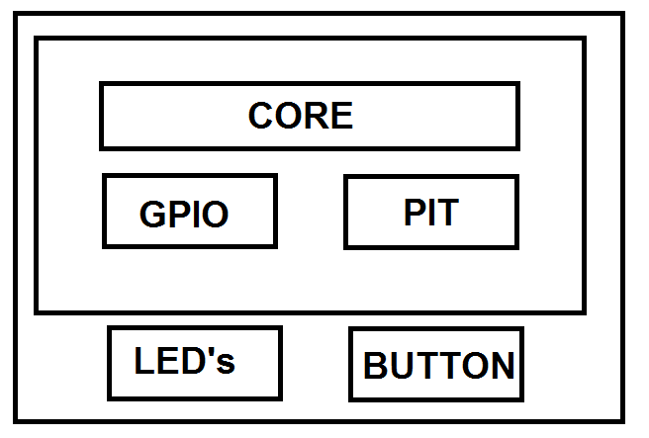

SW Component internal breakdown
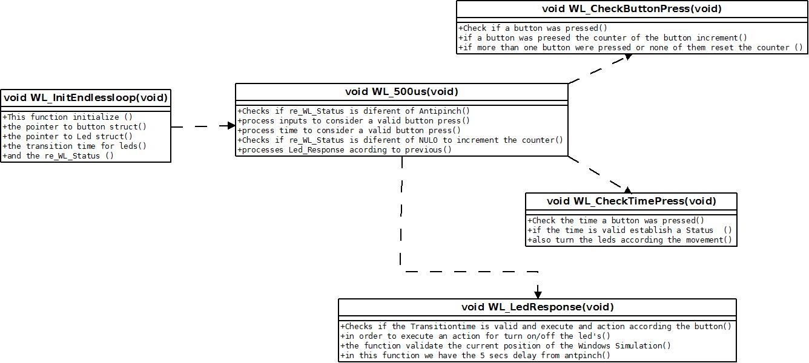
Function Description and Dynamic Behavior

Function void WL_Init(void)

Description | This function is executed only once, this function initialize the two buttons, the antipinch, the led bar, the led indicator, the initial state, and the time for a transition between leds,
Parameter 1 | void
Return Value | void
Precondition | The task of 1ms must be active
Post condition
Error Conditions

Dynamic Behavior
Initialize Button_UP, Button_DOWN, Button_ANTIPINCH, LED_Bar, LED_Indicator, State = IDLE, Time=TimeTransition, Basic_Functionality= Innvalid.

Function void WL_Read_1MS(void)

Description | This function is in charge that only one button is pressed at the time, and increment the counter Time_in_High from the button pressed
Parameter 1 | Void
Return Value | Void
Precondition | The task of 1ms must be active
Post condition
Error Conditions

Dynamic Behavior
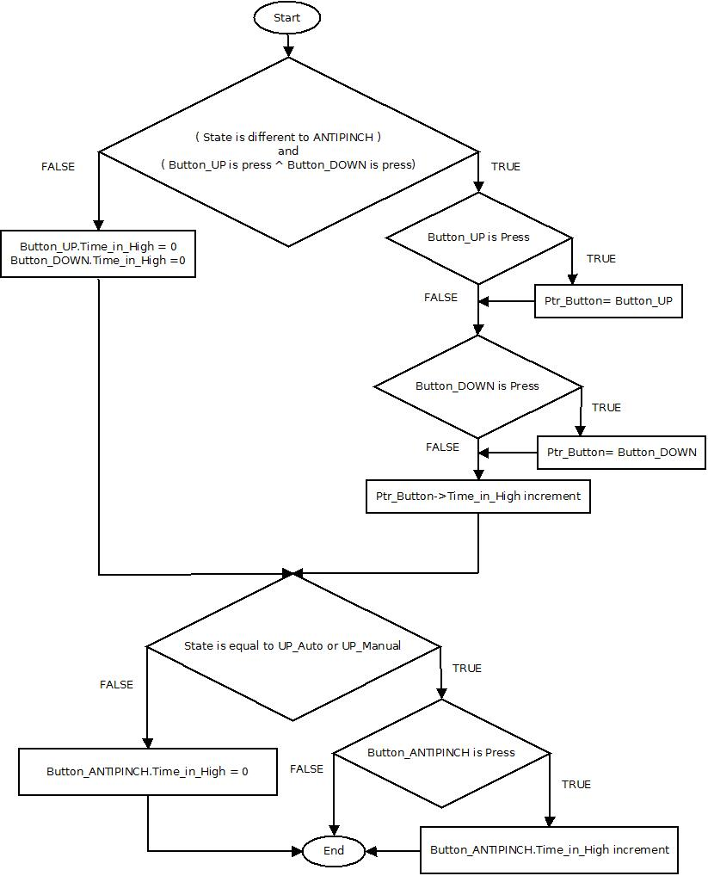

Function void WL_TimeValidation_1MS(void)

Description | This function is responsible for monitoring when a button or antipinch reach certain amount of time, and when this happen some functionality is activated
Parameter 1 | Void
Return Value | Void
Precondition | The task of 1ms must be active and the Ptr_Button.Time_in_High must reach certain value
Post condition | Activate some Functionality
Error Conditions

Dynamic Behavior

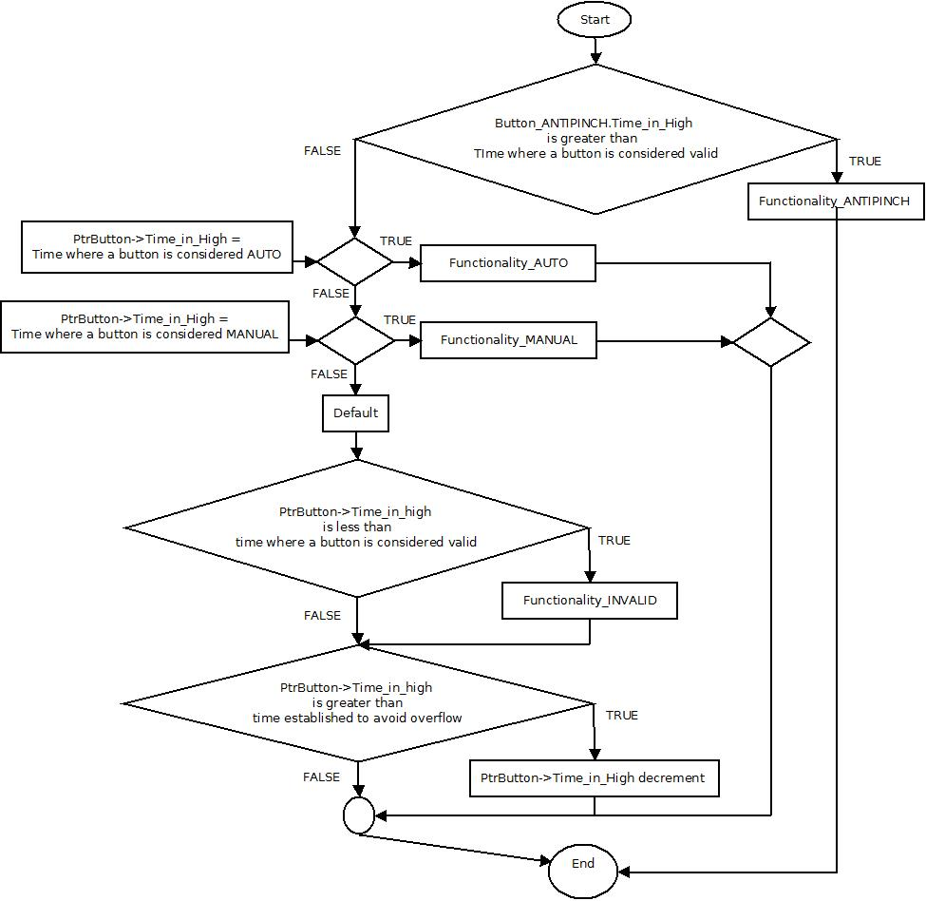

Function void dummy_Check_Time_Press(void)

Description | This function is responsible for monitoring the time that a button has been pressed and select whether the state is AUTO, MANUAL ANTIPINCH or NULO,
Parameter 1 | Void
Return Value | Void
Precondition | re_WL_Status must be different of PINCH
Post condition | Establish the state of the variable re_WL_Status
Error Conditions

Dynamic Behavior

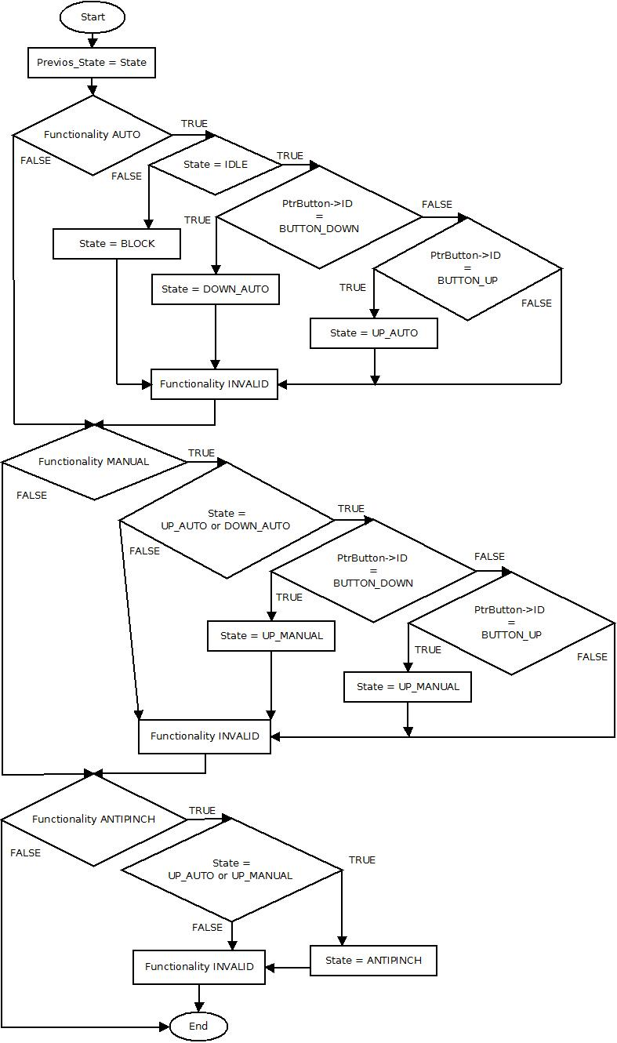

Function void dummy_Led_Response(void)

Description | This function is responsible for the secure and correct time simulation of the WL according to the Button pressed
Parameter 1 | Void
Return Value | Void
Precondition
Post condition
Error Conditions

Dynamic Behavior

